AI ASSISTENT CODING 12.3

Name : P.Deepak
2303A52179
Batch - 42

Task 1: Sorting Student Records for Placement Drive
Scenario
SR University’s Training and Placement Cell needs to shortlist candidates
efficiently during campus placements. Student records must be sorted by
CGPA in descending order.
Tasks
1. Use GitHub Copilot to generate a program that stores student records
(Name, Roll Number, CGPA).
2. Implement the following sorting algorithms using AI assistance:
o Quick Sort
o Merge Sort
3. Measure and compare runtime performance for large datasets.
4. Write a function to display the top 10 students based on CGPA.

Prompt:
Generate a Sorting Student Records for Placement Drive
Generate a program (preferably in Python or Java) to manage student records containing Name, Roll Number, and CGPA.Use GitHub Copilot / AI assistance to implement Quick Sort and Merge Sort to sort students by CGPA in descending order.
Create a large dataset of student records and measure runtime performance of both algorithms using appropriate timing functions.Compare and print the execution time of Quick Sort vs Merge Sort.
Finally, implement a function to display the top 10 students based on CGPA with clear, formatted output.

Code:
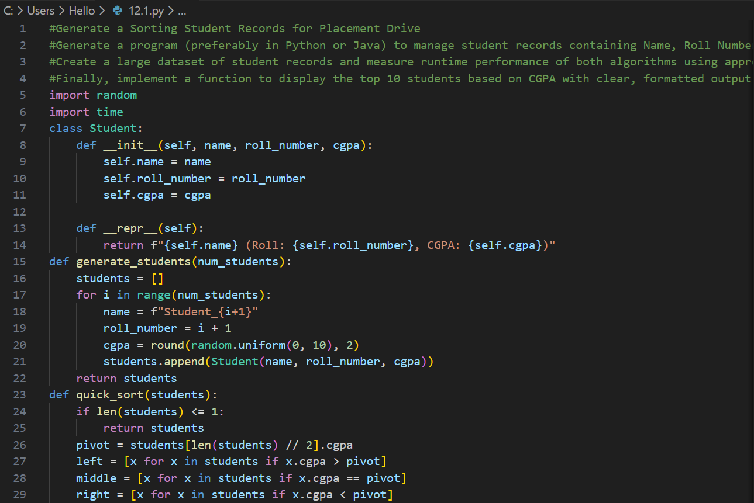
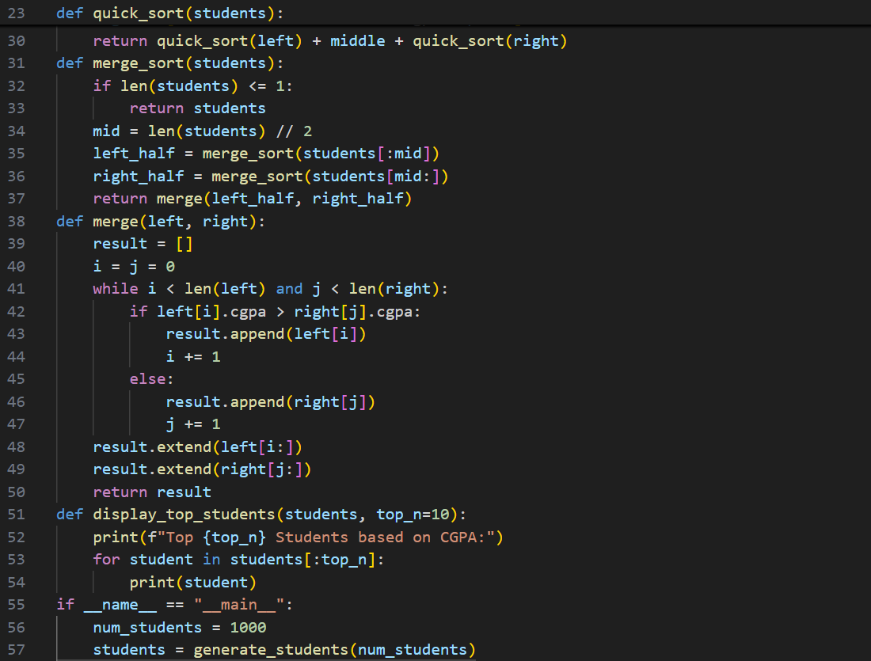
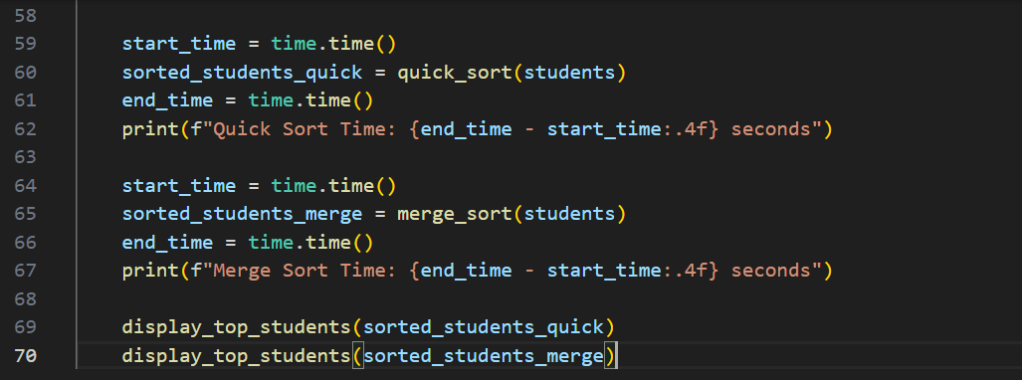

Output :
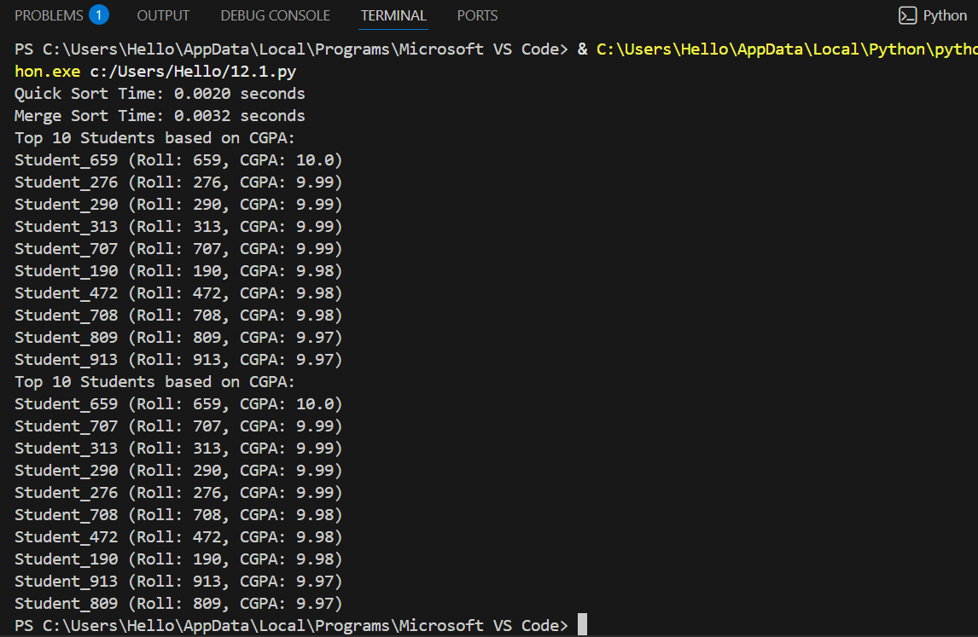

Justification :
This task uses AI tools to efficiently store and sort student records based on CGPA. Sorting in descending order helps the Training and Placement Cell quickly identify top-performing students. Implementing Quick Sort and Merge Sort allows comparison between two efficient algorithms, ensuring correct ranking and understanding of performance differences on large datasets.

Task 2: Implementing Bubble Sort with AI Comments
• Task: Write a Python implementation of Bubble Sort.
• Instructions:
• Students implement Bubble Sort normally.
• Ask AI to generate inline comments explaining key logic (like
swapping, passes, and termination).
• Request AI to provide time complexity analysis

Prompt:
Write a Python program to implement the Bubble Sort algorithm for sorting a list of numbers in ascending order.
Add AI-generated inline comments explaining the key logic, including comparisons, swapping of elements, number of passes, and when the algorithm stops.
Ensure the code is clean, readable, and beginner-friendly.
After the code, provide a time complexity analysis of Bubble Sort for best case, average case, and worst case in simple terms.

Code:
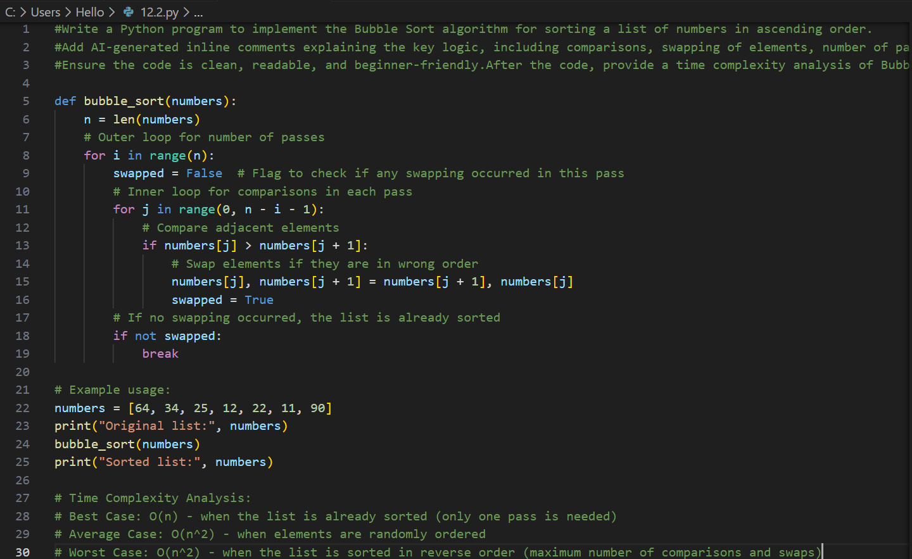

Output :
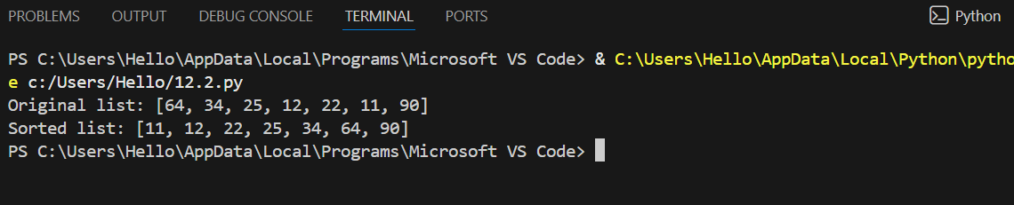

Justification :
Bubble Sort is chosen because it is simple and easy to understand for beginners. AI-generated inline comments help explain the logic behind comparisons, swapping, and loop termination. Time complexity analysis improves understanding of why Bubble Sort is inefficient for large datasets, making this task useful for learning algorithm fundamentals.

Task 3: Quick Sort and Merge Sort Comparison
• Task: Implement Quick Sort and Merge Sort using recursion.
• Instructions:
• Provide AI with partially completed functions for recursion.
• Ask AI to complete the missing logic and add docstrings.
• Compare both algorithms on random, sorted, and reverse-sorted
lists.
• Expected Output:
• Working Quick Sort and Merge Sort implementations.
• AI-generated explanation of average, best, and worst-case
complexities.

Prompt:
Given partially completed recursive functions for Quick Sort and Merge Sort in Python, complete the missing logic using proper recursion.
Add clear docstrings explaining the purpose, parameters, and return values of each function.
Generate test cases using random, already sorted, and reverse-sorted lists and apply both algorithms to them.
Measure and compare execution time for each input type.
Finally, provide an AI-generated explanation of best-case, average-case, and worst-case time complexities for Quick Sort and Merge Sort in simple terms.

Code:
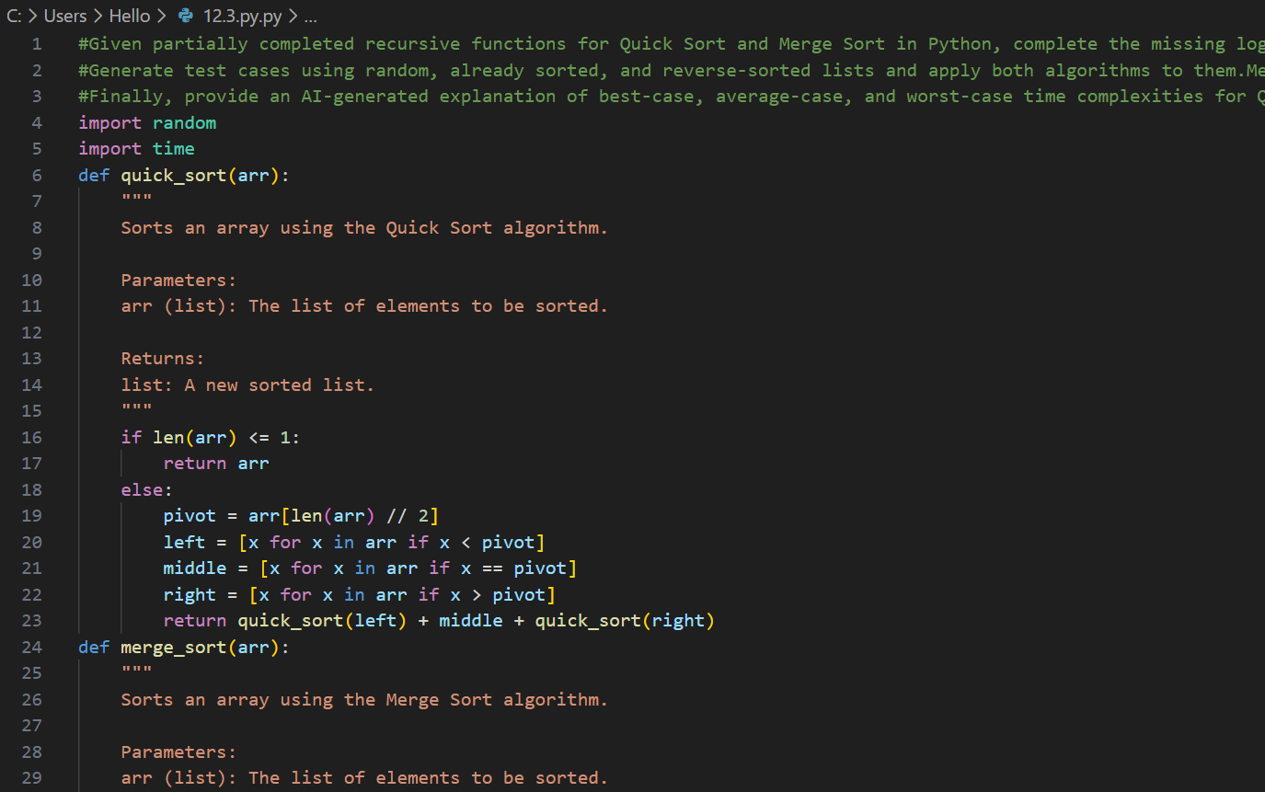
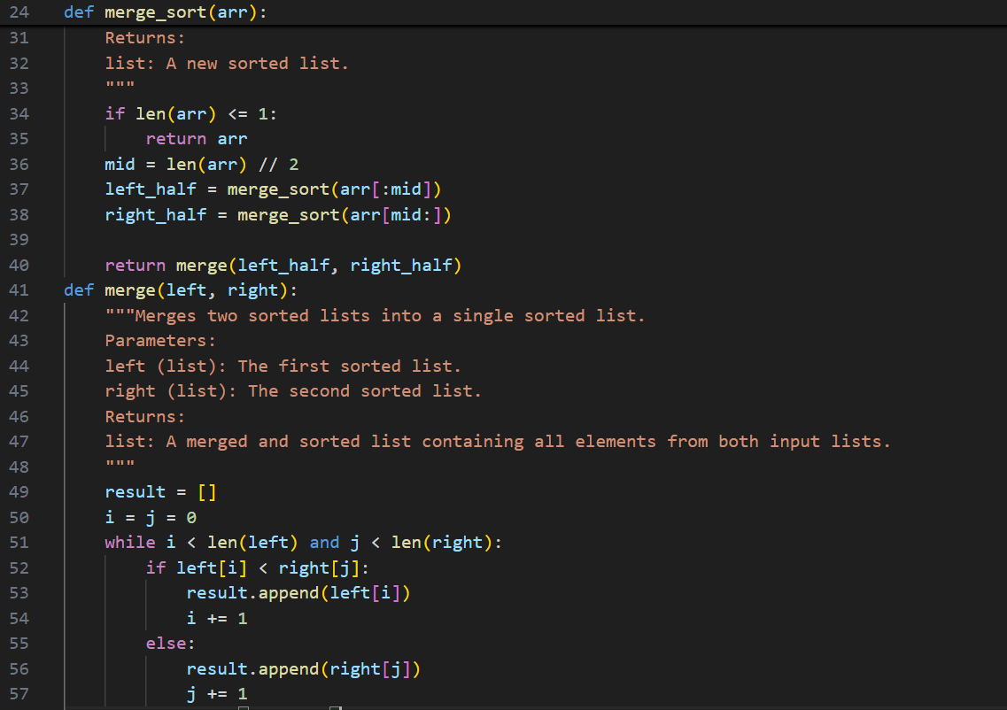
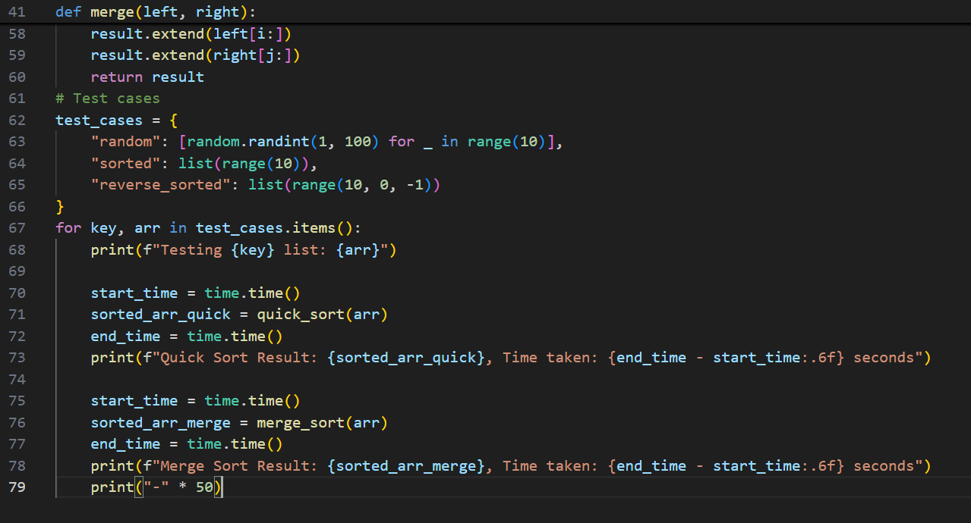

Output:
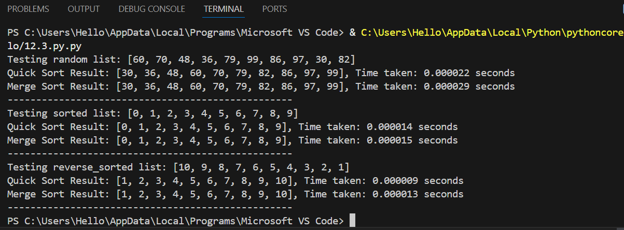

Justification:
This task demonstrates the use of recursion in sorting algorithms. By comparing Quick Sort and Merge Sort on random, sorted, and reverse-sorted data, students understand how input order affects performance. AI explanations of best, average, and worst-case complexities help in analyzing algorithm efficiency in real-world scenarios.

Task 4 (Real-Time Application – Inventory Management System)
Scenario: A retail store’s inventory system contains thousands of products,
each with attributes like product ID, name, price, and stock quantity. Store staff
need to:
1. Quickly search for a product by ID or name.
2. Sort products by price or quantity for stock analysis.
Task:
• Use AI to suggest the most efficient search and sort algorithms for this
use case.
• Implement the recommended algorithms in Python.
• Justify the choice based on dataset size, update frequency, and
performance requirements.

Prompt:
Design a real-time Inventory Management System in Python for a retail store containing thousands of products with attributes Product ID, Name, Price, and Stock Quantity.
Use AI assistance to recommend the most efficient searching and sorting algorithms for this use case.
Create a table mapping each operation (search/sort) to the chosen algorithm with justification based on dataset size, update frequency, and performance needs.
Implement Python functions to search products by ID or name and sort products by price or quantity.
Ensure the output is clear, efficient, and suitable for a real-world application.

Code:
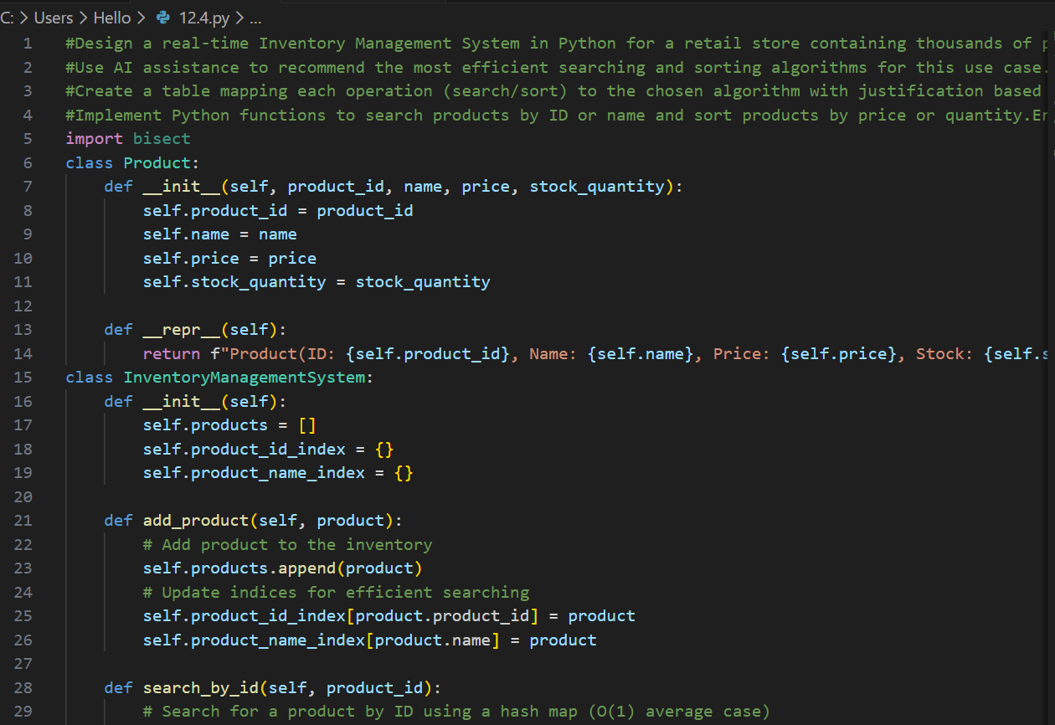
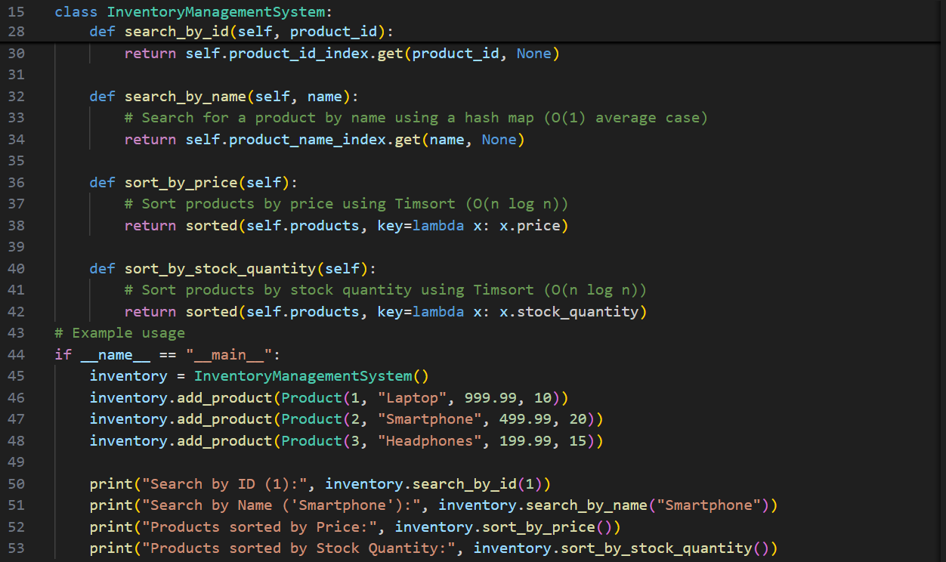
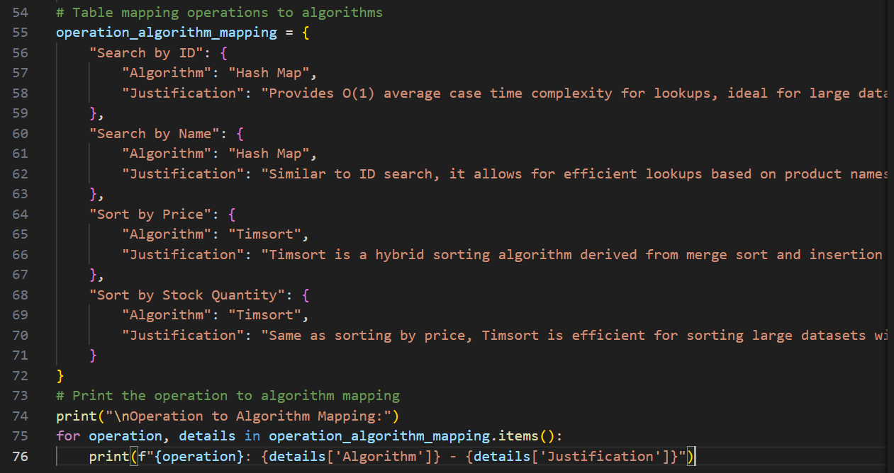

Output:
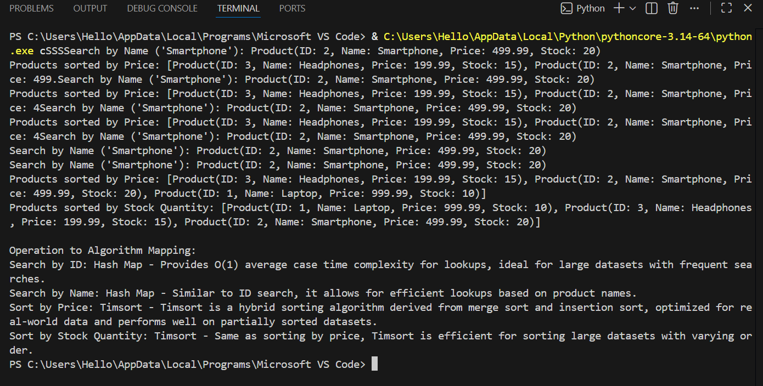

Justification:
An inventory system requires fast searching and sorting due to large data size and frequent updates. Hash Maps are used for searching because they provide instant access to products. Quick Sort and Merge Sort are chosen for efficient sorting by price and quantity. This task shows how algorithm selection depends on performance requirements and real-time usage.
Task 5: Real-Time Stock Data Sorting & Searching
Scenario:
An AI-powered FinTech Lab at SR University is building a tool for analyzing
stock price movements. The requirement is to quickly sort stocks by daily
gain/loss and search for specific stock symbols efficiently.
• Use GitHub Copilot to fetch or simulate stock price data (Stock
Symbol, Opening Price, Closing Price).
• Implement sorting algorithms to rank stocks by percentage change.
• Implement a search function that retrieves stock data instantly when a
stock symbol is entered.
• Optimize sorting with Heap Sort and searching with Hash Maps.
• Compare performance with standard library functions (sorted(), dict
lookups) and analyze trade-offs.

Prompt:
Build a real-time stock analysis tool in Python for an AI-powered FinTech Lab.
Use GitHub Copilot / AI assistance to fetch or simulate stock data containing Stock Symbol, Opening Price, and Closing Price.
Implement a sorting algorithm to rank stocks by daily percentage gain/loss, optimizing the solution using Heap Sort.
Implement an efficient search function using Hash Maps to instantly retrieve stock details when a stock symbol is entered.
Compare the performance of custom algorithms with Python standard library functions (sorted(), dictionary lookups) and analyze the trade-offs.

Code:
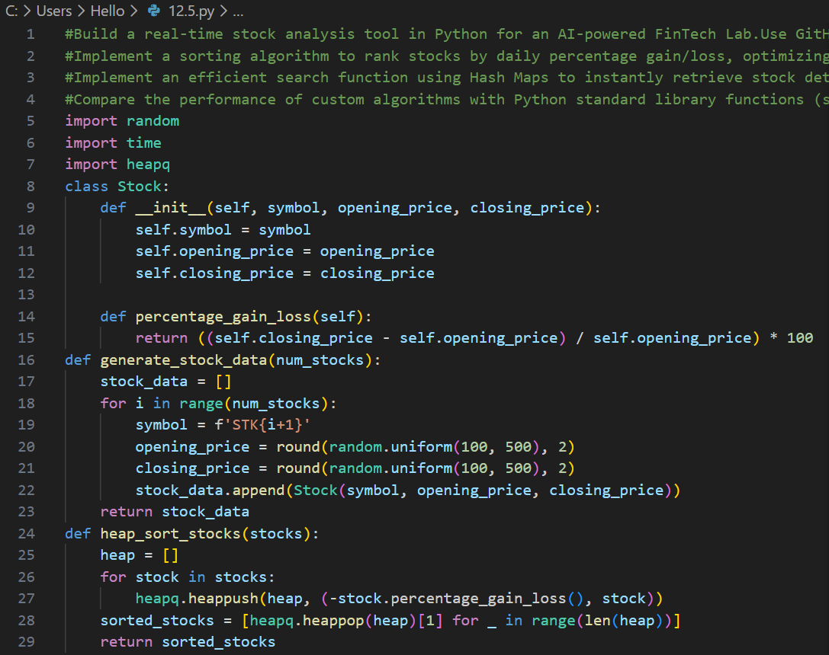
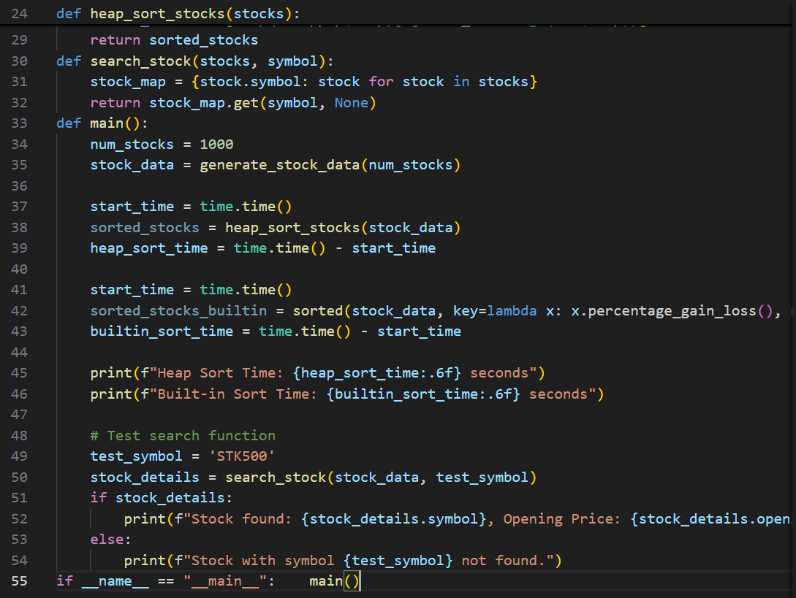

Output:
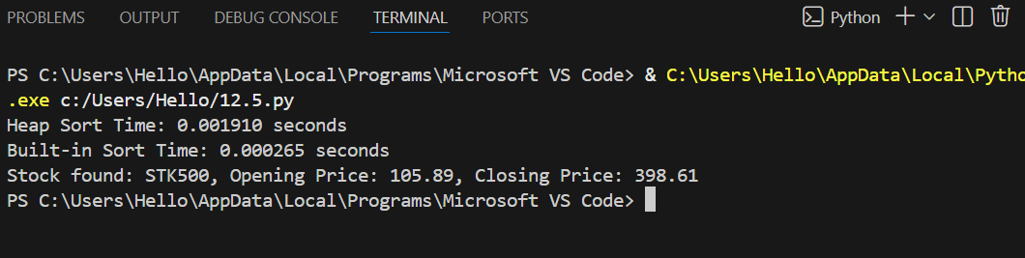

Justification:
Stock market analysis requires real-time performance and fast data access. Heap Sort is used to rank stocks by percentage gain/loss efficiently, while Hash Maps enable instant stock symbol search. Comparing custom algorithms with Python built-in functions helps understand trade-offs between learning concepts and practical efficiency in real-world financial applications.

